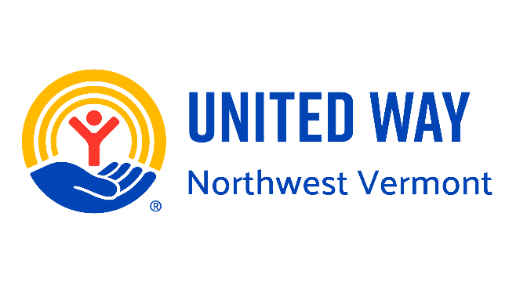

**United Way of Northwest Vermont**

**2025 Stock Gift Instructions**

**Contact Ayeshah Raftery, Major Gifts & Planned Gift Manager,** [**ayeshah@unitedwaynwvt.org**](mailto:ayeshah@unitedwaynwvt.org)

**or 802-861-7831 and provide the following information:**

Date of gift

Donor name(s) and address

Name of security and number of shares

**For DTC eligible securities transfer, arrange to have the securities transferred to United Way’s account with the following information:**

DTC # 0990 – Manufacturers & Traders Trust Company (M&T Bank)

Inst ID # 26667, Agent Bank # 26668

FBO: United Way of NWVT – Cash Management Account

A/C# 62A005016

**Fed Eligible Securities**

FED Book Entry:

MFRS BUF / Trust (1050)

N/O M&T Bank

ABA# 022000046

FBO: United Way of NWVT – Cash Management Account

A/C# 62A005016

**Bank contact information if needed:**

Michelle M. Buswell, CFP®

SVP Wealth Advisor

Wilmington Trust N.A. | An M&T Company

802-652-6162 | (C) 802-233-5987

[mbuswell@wilmingtontrust.com](mailto:mbuswell@wilmingtontrust.com) | wilmingtontrust.com

77 Pine Street, Suite 100, Burlington, VT 05401